Docking Station - special designed for PC accessible with 2.5” SATA HDD directly

- Model ：ITS-DTD-25eS (3.5” Docking for 2x 2.5〞SATA HDD)。
- Connection ：SATA to SATA。
- Color ：White / Black
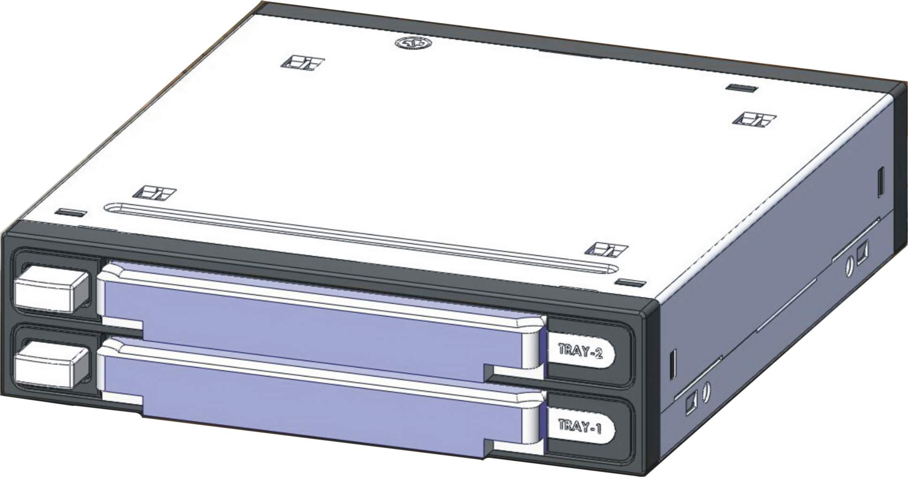
- Size ：110*102*26mm。
- Construction ：reject buttons,
ABS VO(front, rear panel)+
SECC（up、down covers）design.

LED indicator
- Two SATA HDD
can be inserted in the same time, two LED indicators, support plug & play.
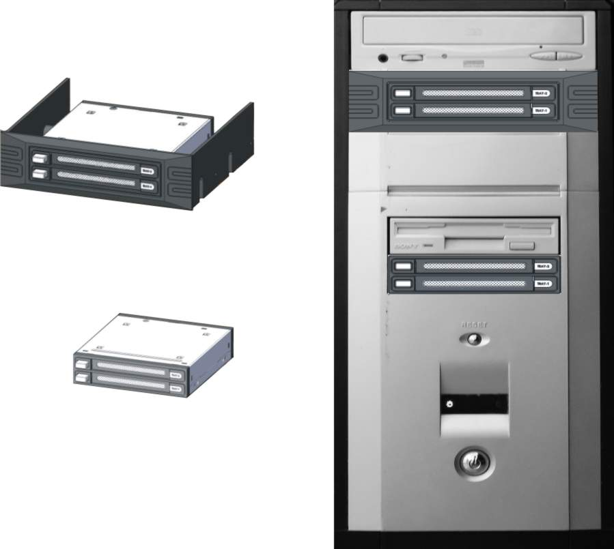
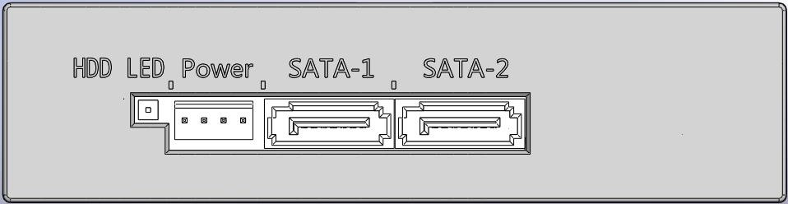
- Direct install to PC 3.5〞front slot, or mount it to CD-ROM slot by a bundled 5.25” panel.

