3.5” DATA TRAY DOCK - special designed for PC accessible with 2x 2.5” SATA HDD directly

- Model ：ITS-DTD-25eS (3.5” internal Docking for 2x 2.5〞SATA HDD)。
- Connection ：SATA to SATA。
- Color ：Beige / Black
- Size ：110*102*26mm。
- Materials : ABS VO(front, rear panel)+SECC（up、down covers）design.
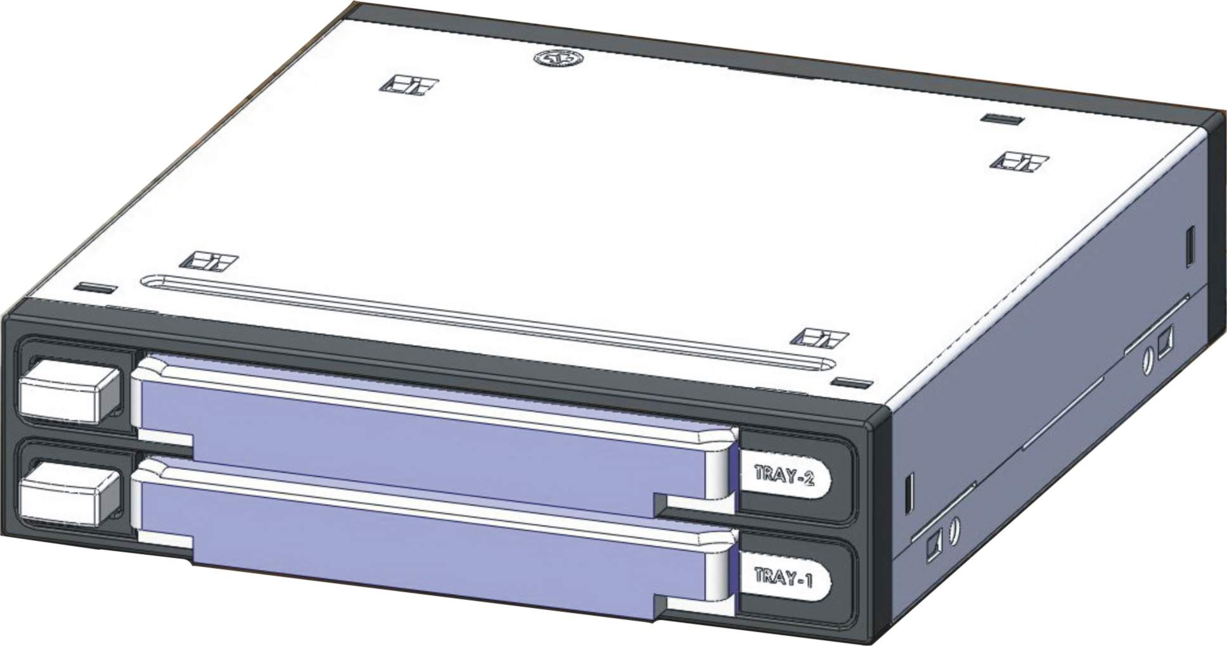
- Construction :
Reject buttons

2x 2.5” SATA HDD
LED indicator
can be inserted in the same time, two LED indicators, support plug & play.
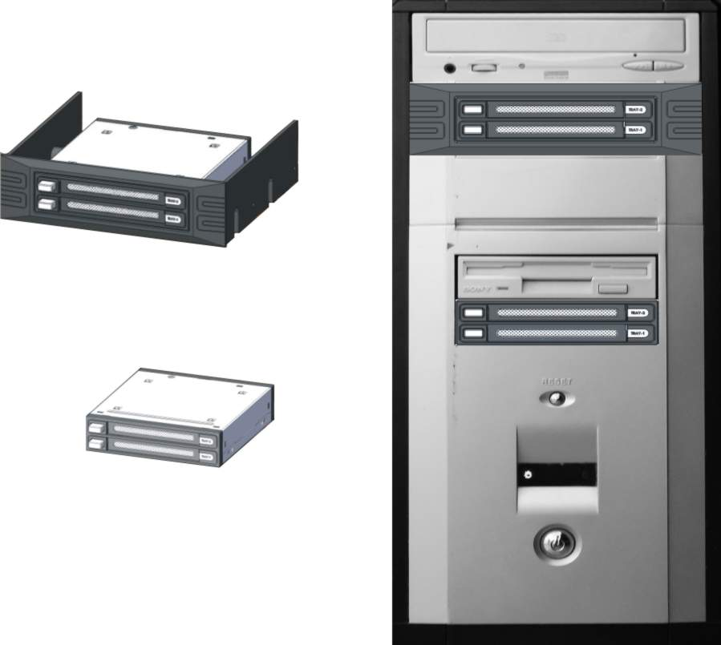
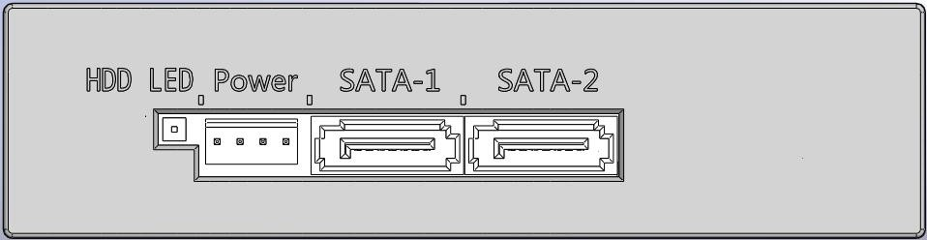
- Direct install to PC 3.5〞front slot, or mount it to CD-ROM slot by a bundled 5.25” panel.

